Lab 5：MATLAB Programming

Authors | Name：何衍宁 Student ID:12311512  Name：夏天 Student ID:12311610
Objective
Lab4
In Lab 4, our primary learning objectives are centered around deepening our understanding of frequency-domain analysis through the use of the continuous-time Fourier transform (CTFT). We aim to develop a strong grasp of how to analyze both periodic and aperiodic signals in the frequency domain, which simplifies the structure of complex time-domain signals. By engaging with various exercises, we will enhance our intuitive understanding of the relationship between time-domain and frequency-domain properties, particularly in the context of linear time-invariant (LTI) systems. Additionally, we will explore practical applications such as using frequency response analyses to understand system behaviors and applying numerical methods to approximate the CTFT. This lab will not only strengthen our theoretical knowledge but also improve our practical skills in handling real-world signal processing challenges.
Lab results & Analysis
1.
1.Generate a speech-shaped noise (SSN), and plot the spectra of the speech signal and SSN (e.g., use Matlab function ‘psd’ or ‘pwelch’, or other power spectral density estimation functions).
The problem requires the generation of the noise spectrum from the existing speech signal, and the spectrum spectrum of the source speech signal, frequency response and speech spectrum noise.
Analysis:
The C_01_01(1).wav. Source on the pilot BB, using the existing sound source generation idiom filter. Then construct a section of white noise, and get spectral noise after filtering the white noise.
clc;
clear;
[x,fs] = audioread('C_01_02.wav');
x = x';
t = linspace(0,length(x)/fs,length(x));

figure;
plot(t,x);
xlabel('x'),
ylabel('y(t)'),
grid on;
legend('y with no rawing');

figure;
y10 = repmat(x,1,10);
nfft = 512;
noverlap = nfft/2;
window = hamming(nfft);
[P,w]=pwelch(y10,window,noverlap,nfft,fs);
b = fir2(3000,w/(fs/2),sqrt(P/max(P)));
[H,W] = freqz(b,1);
plot(W,abs(H));
xlabel('w'),
ylabel('H(jw)'),
grid on;
legend('H(jw)');

figure;
N = length(x);
noise = 1-2*rand(1,N);
SSN = filter(b,1,noise);
plot(t,SSN);
xlabel('t'),
ylabel('SSN(t)'),
grid on;
legend('SSN(t)');
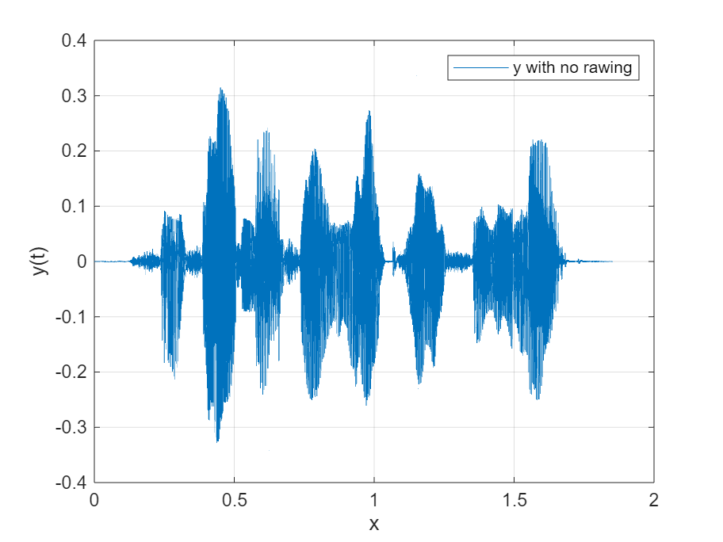
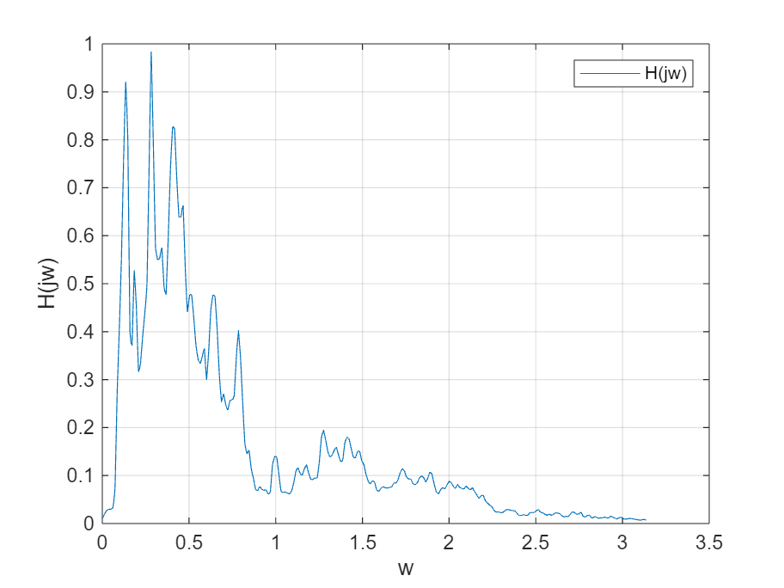
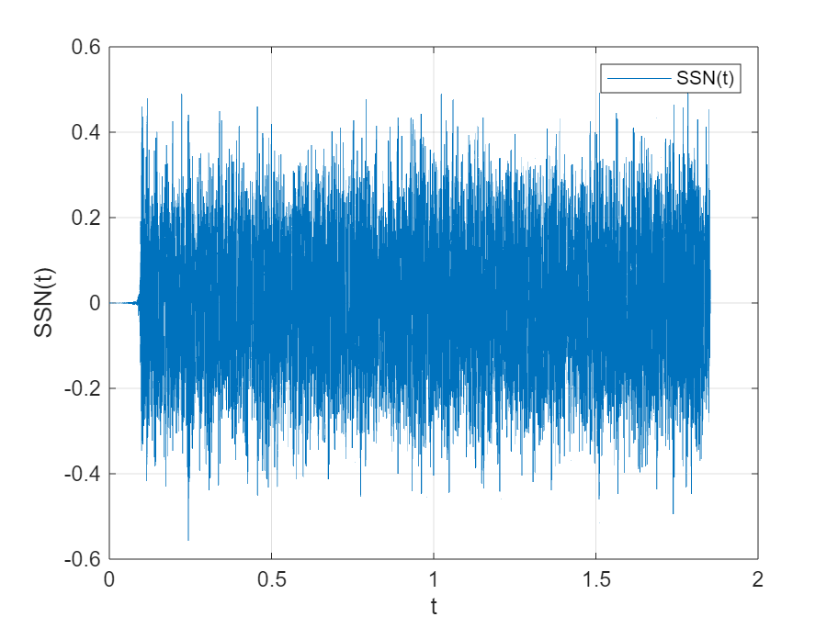

Lab result:
The image of the original sound signal, the frequency response of the filter, and the resulting spectral noise are shown in the figure.
2.
The problem requires that under the SNR of -5 dB, speech spectral noise is added to the original speech signal to generate a noisy signal, and then the energy of the noisy signal y relative to x(t) of the original speech signal is standardized.
Analysis:
SNR = -5 = 20*lg(norm(x)/norm(SSN)),norm(SSN)=norm(x)*10^(1/4).

Thus, the energy of spectral noise is adjusted to verify the signal-to-noise ratio. The adjusted spectrum noise is added to the original signal to generate a signal with noise, and then the noise is adjusted
The signal energy is the same as the original signal。
clc;
clear;
[x,fs] = audioread('C_01_02.wav');
x = x';
t = linspace(0,length(x)/fs,length(x));

y10 = repmat(x,1,10);
nfft = 512;
noverlap = nfft/2;
window = hamming(nfft);
[P,w]=pwelch(y10,window,noverlap,nfft,fs);
b = fir2(3000,w/(fs/2),sqrt(P/max(P)));
[H,W] = freqz(b,1);

N = length(x);
noise = 1-2*rand(1,N);
SSN = filter(b,1,noise);

figure;
SSNf = SSN/norm(SSN)*norm(x)*(10^0.25);
SNR = 20*log10(norm(x)/norm(SSNf));
y0 = x+SSNf;
y = y0/norm(y0)*norm(x);
plot(t,y);
xlabel('t'),
ylabel('y(t)'),
grid on;
legend("y(t)");
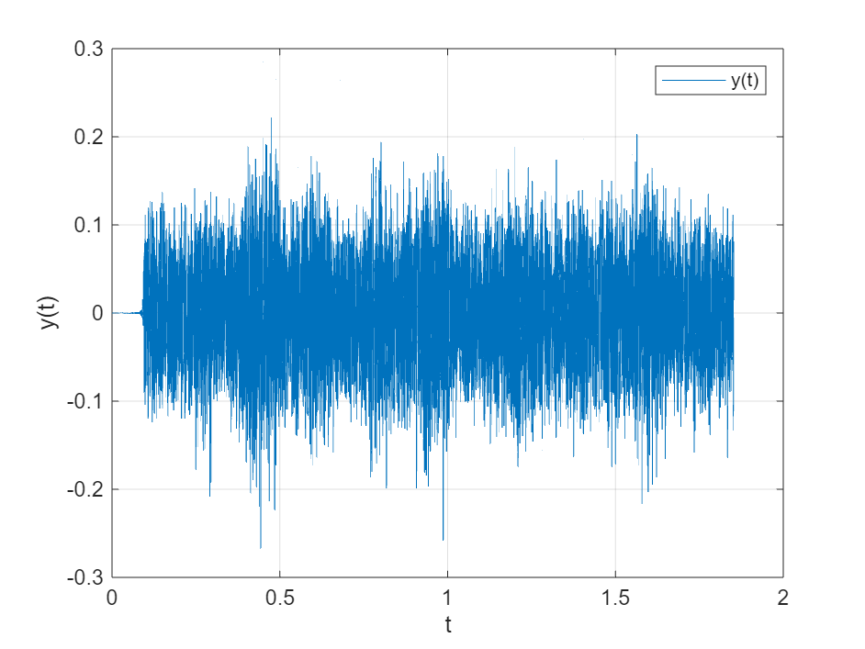

Lab result:
The resulting noisy sound is shown in the figure.
3.
The envelopments are obtained with second-order 100Hz,200Hz,300Hz and sixth-order 200Hz Butterworth low-pass filters, and the differences are compared. The envelope of the original signal is used here.
3. Extract speech envelope
1) with 2nd-order low-pass filter and cutoff frequency fcut= 100, 200, and 300 Hz. Plot these three envelope waveforms in one plot, and describe the difference among them.
2) with 2nd and 6th-order low-pass filter and cutoff frequency 200 Hz. Plot these two envelope waveforms in one plot, and describe the difference between them.
Analysis:
The Butterworth filter is constructed according to the order and cut-off frequency shown in the question
tclc;
clear;
[x,fs] = audioread('C_01_02.wav');
x = x';
t = linspace(0,length(x)/fs,length(x));

y10 = repmat(x,1,10);
nfft = 512;
noverlap = nfft/2;
window = hamming(nfft);
[P,w]=pwelch(y10,window,noverlap,nfft,fs);
b = fir2(3000,w/(fs/2),sqrt(P/max(P)));
[H,W] = freqz(b,1);

N = length(x);
noise = 1-2*rand(1,N);
SSN = filter(b,1,noise);

SSNf = SSN/norm(SSN)*norm(x)*(10^0.25);
SNR = 20*log10(norm(x)/norm(SSNf));
y0 = x+SSNf;
y = y0/norm(y0)*norm(x);

figure
[b1,a1] = butter(2,100/(0.5*fs));
[b2,a2] = butter(2,200/(0.5*fs));
[b3,a3] = butter(2,300/(0.5*fs));
[b4,a4] = butter(6,200/(0.5*fs));
yb1 = filter(b1,a1,abs(x));
yb2 = filter(b2,a2,abs(x));
yb3 = filter(b3,a3,abs(x));
yb4 = filter(b4,a4,abs(x));
subplot(3,1,1)
plot(t,yb1),
xlabel('t'),
ylabel("Envelop Wave"),
grid on,
legend("Order=2,f=100hz");
subplot(3,1,2)
plot(t,yb2),
xlabel('t'),
ylabel("Envelop Wave"),
grid on,
legend("Order=2,f=200hz");
subplot(3,1,3)
plot(t,yb3),
xlabel('t'),
ylabel("Envelop Wave"),
grid on,
legend("Order=2,f=300hz");

figure
subplot(2,1,1)
plot(t,yb1),
xlabel('t'),
ylabel("Envelop Wave"),
grid on,
legend("Order=2,f=200hz");
subplot(2,1,2)
plot(t,yb1),
xlabel('t'),
ylabel("Envelop Wave"),
grid on,
legend("Order=6,f=200hz");

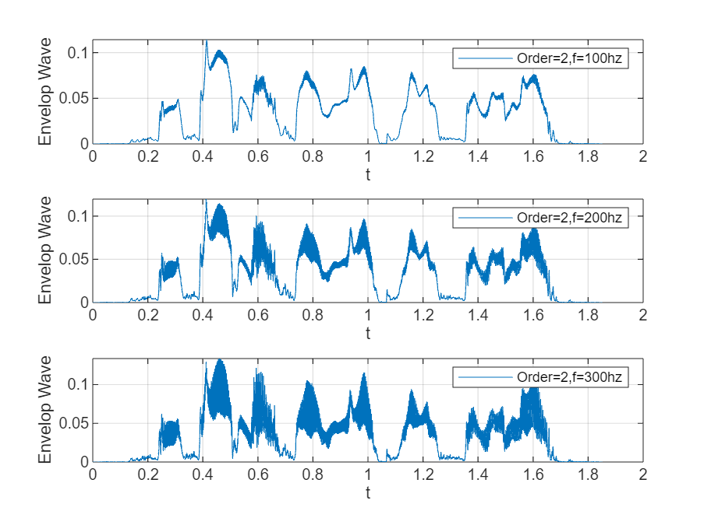
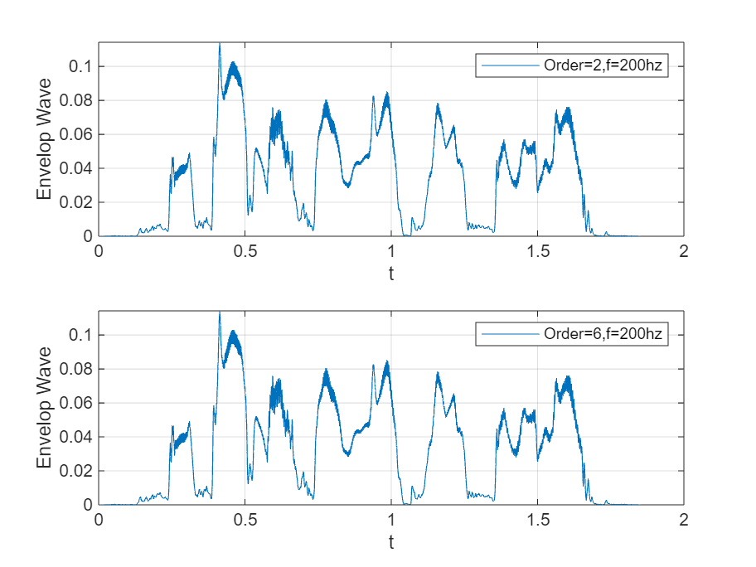
Lab result:
From the picture,
1、 The order is the same, the cut-off frequency is different, and the filter with a higher cut-off frequency can retain the high-frequency signal and reduce distortion.
2、 When the cutoff frequency is the same and the order is different, the filter with higher order has better filtering effect. The acquisition envelope is more complete, and fewer high-frequency signals are missed.

4.
4. One *.wav files for lab 5 and the coming lab project 1: ‘C_01_02.wav’

Analysis:
Record an audio signal and save it as a.wav file
clc;
clear;
[x,fs] = audioread('C_01_02.wav');
x = x';
t = linspace(0,length(x)/fs,length(x));

y10 = repmat(x,1,10);
nfft = 512;
noverlap = nfft/2;
window = hamming(nfft);
[P,w]=pwelch(y10,window,noverlap,nfft,fs);
b = fir2(3000,w/(fs/2),sqrt(P/max(P)));
[H,W] = freqz(b,1);

N = length(x);
noise = 1-2*rand(1,N);
SSN = filter(b,1,noise);

SSNf = SSN/norm(SSN)*norm(x)*(10^0.25);
SNR = 20*log10(norm(x)/norm(SSNf));
y0 = x+SSNf;
y = y0/norm(y0)*norm(x);

audiowrite('new_signal.wav',y0,fs);
Lab result:
The audio saved after processing has a noticeable noise, but the original content can still be heard.

Note: Please indicate meaning of the symbols in all expressions. Please indicate the coordinate and unit in all figures.
Experience
- The mathematical foundation required for understanding the CTFT can be quite complex, especially for those new to signal processing. To address this, we will focus on building a strong conceptual understanding through step-by-step tutorials and hands-on exercises. Engaging with additional resources such as instructional videos, and collaborative study sessions can also help in demystifying the more intricate parts of the theory.
- Applying theoretical concepts of the CTFT to real-world problems can be challenging due to the abstract nature of frequency-domain analysis. To bridge this gap, we will use simulation tools and software to visualize the effects of transformations and to conduct practical experiments. This hands-on approach will help us see the direct impact of theoretical principles in practical scenarios, enhancing our learning experience.
- The use of software tools and functions like freqs and fourier for computing CTFTs and analyzing system responses requires some familiarity with numerical computation. To overcome this challenge, we will provide detailed guidelines and practice exercises focusing on these tools. Learning these computational techniques in a step-by-step manner will equip us with the necessary skills to effectively use technology in analyzing and solving signal processing problems.
Score | 100/100

字体：英文Times new Roman；

